Project Report
ESP32 Wi-Fi Controlled RC Car
Name: Tirth kushwaha
Class: SE E&TC A 48

1. Introduction
This project focuses on converting an old remote-controlled toy car into a Wi-Fi-controlled robotic vehicle using the ESP32 microcontroller. Instead of relying on the stock RF remote system, a custom wireless control interface was developed using a web server hosted directly on the ESP32 in Wi-Fi Access Point (AP) mode.
The objective of this project was to gain practical experience in embedded systems, motor driver interfacing, wireless communication, power management, and real-time control using ESP32.
2. Objectives
- Develop a wireless robotic vehicle using ESP32
- Implement browser-based control using Wi-Fi AP mode
- Interface motors using TB6612FNG motor driver
- Learn practical power management techniques
- Understand motor noise isolation and brownout prevention
- Explore embedded + IoT integration in a real hardware setup
3. Components Used
Component | Purpose
ESP32 DevKit | Main microcontroller and Wi-Fi communication
TB6612FNG Motor Driver | Motor control
DC Motors | Vehicle movement
Old RC Car Chassis | Mechanical platform
18650 Cells | Power supply
Buck Converter | Voltage regulation
Jumper Wires | Connections
Breadboard / PCB | Prototyping

4. Circuit Diagram (representation)
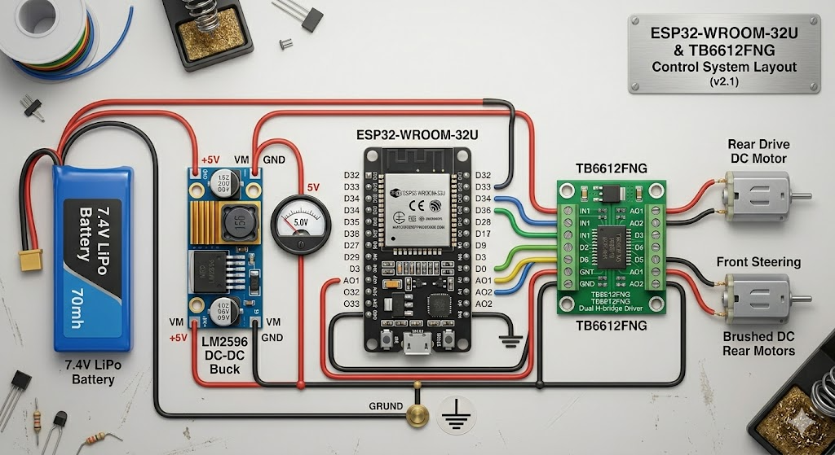
5. Working Principle
The ESP32 hosts a lightweight web server while operating in Wi-Fi AP mode. A smartphone connects directly to the ESP32 network and accesses the control webpage through a browser.
The webpage sends movement commands such as:
- Forward
- Backward
- Left
- Right
- Stop
These commands are processed by the ESP32, which controls the TB6612FNG motor driver to drive the motors accordingly.
The motor driver provides bidirectional control of the motors, enabling differential drive movement.
6. Source Code
Project source code and implementation files can be accessed using the link below:
CODE FOR IT

7. Power Architecture
A separate 2-cell battery supply was used for the ESP32 because Wi-Fi communication requires stable current delivery. During wireless transmission, sudden current demand can cause voltage drops, leading to ESP32 brownout resets.
A separate motor power supply was used for the TB6612FNG and motors to isolate motor noise and current spikes from the control electronics.
A buck converter was used to regulate voltage and provide stable operation.
8. Why TB6612FNG Instead of L298N
The TB6612FNG motor driver was chosen instead of the L298N because:
- Lower voltage drops
- Higher efficiency
- MOSFET-based design
- Reduced heat generation
- Better battery utilization
- More compact size
- Better suited for low-voltage embedded systems
9. ESP32 Features Used
- Wi-Fi AP Mode
- Web Server Hosting
- GPIO Control
- PWM-based motor control
- Embedded wireless communication
10. Challenges Faced
- Motor noise affecting system stability
- Voltage fluctuations during motor startup
- Brownout resets due to Wi-Fi current demand
- Power isolation and grounding issues
- Mechanical alignment of the old RC chassis

11. Learning Outcomes
Through this project, the following concepts were explored practically:
- Embedded system integration
- Wi-Fi-based communication
- Web server implementation on ESP32
- Motor driver interfacing
- Differential drive control
- Power management and supply isolation
- Practical debugging and hardware troubleshooting
12. Applications
- Wireless robotic vehicles
- IoT robotics platforms
- Educational embedded systems projects
- Remote-controlled automation systems
- Mobile-controlled robotic platforms
13. Future Improvements
- PWM speed control implementation
- Obstacle avoidance using sensors
- ESP-NOW communication
- Camera integration
- Mobile application interface
- PCB-based compact design
14. Conclusion
This project successfully demonstrated the implementation of a Wi-Fi-controlled robotic vehicle using ESP32 and TB6612FNG motor driver. The project provided practical exposure to embedded systems, wireless communication, motor control, and power management.
The conversion of an old RC car into a browser-controlled robotic platform also highlighted the importance of system integration, modular design, and real-world hardware debugging in embedded engineering.

